Vrinda bangla font setup in Jasper studio

Step1 : download font vrinda.ttf font

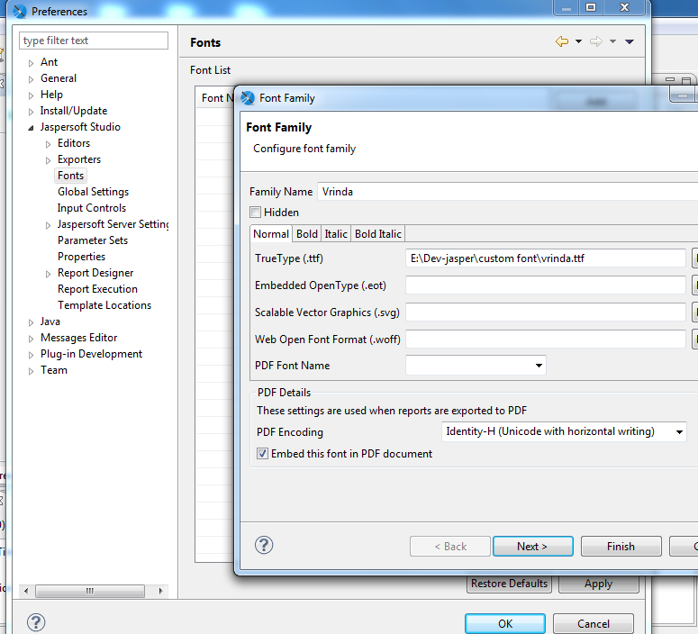

Step 2 : select and use this Vrinda font in textfield

